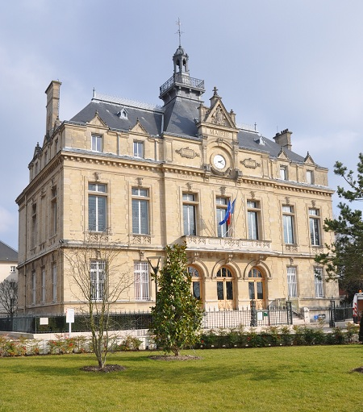

[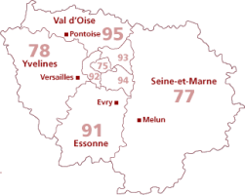](https://www.google.fr/url?sa=i&rct=j&q=&esrc=s&source=images&cd=&cad=rja&uact=8&ved=2ahUKEwjtkYf24r7hAhVnxYUKHVmIBRwQjRx6BAgBEAU&url=https://fr.geneawiki.com/index.php/Histoire_locale_%C3%8Ele-de-France&psig=AOvVaw2kh4diTrD-amgeZeR3tFp6&ust=1554753668106434)

